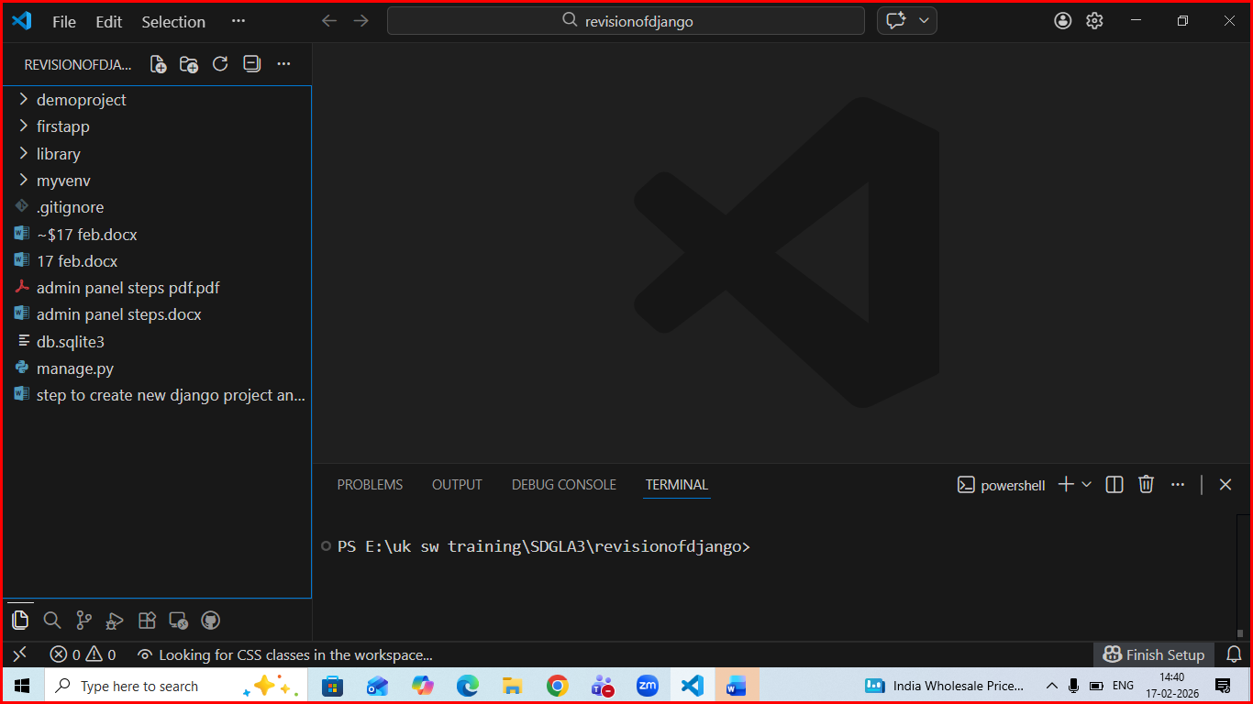
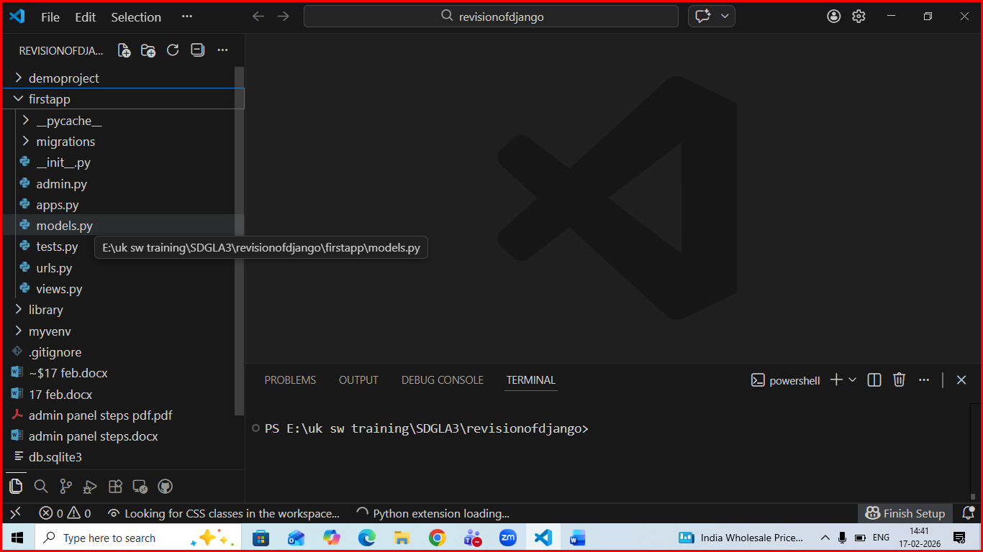
Below is code of models.py fo firstapp which contains model for user and cuisines
from django.db import models
# Create your models here.
class User(models.Model):
name = models.CharField(max_length=25)
email = models.EmailField()
def __str__(self):
return self.name
#cuisine model
STATUS_CHOICES = (
('draft', 'Draft'),
('published', 'Published'),
)
CATG_CHOICES = (
('dessert', 'Dessert'),
('snack', 'Snack'),
('food', 'Food'),
)

class Cuisine(models.Model):
name = models.CharField(max_length=20)
type = models.CharField(max_length=15, choices = (('veg','Veg'),('non veg','NON Veg')), default = 'non veg')
catg = models.CharField(max_length=8, choices=CATG_CHOICES,default = 'food')
desc =models.TextField()
author = models.ForeignKey(User, related_name='cuisine_user', on_delete=models.CASCADE)

created = models.DateTimeField(auto_now_add=True)
updated = models.DateTimeField(auto_now=True)
# slug = models.SlugField(max_length=30, unique_for_date='publish')
status = models.CharField(max_length=10,
choices=STATUS_CHOICES,
default='draft')

def __str__(self):
return self.name

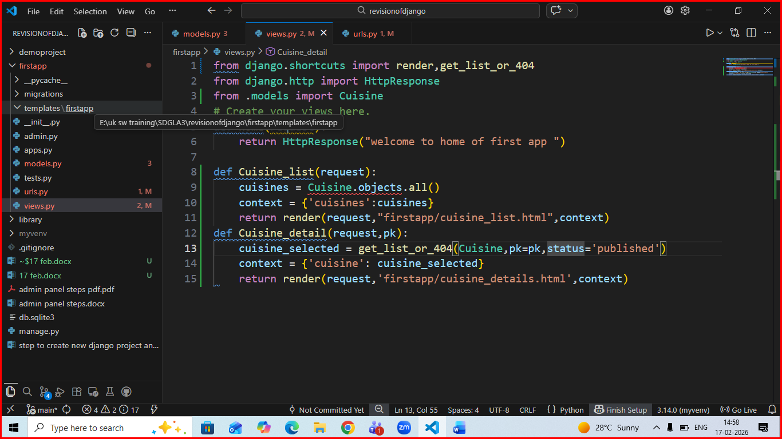
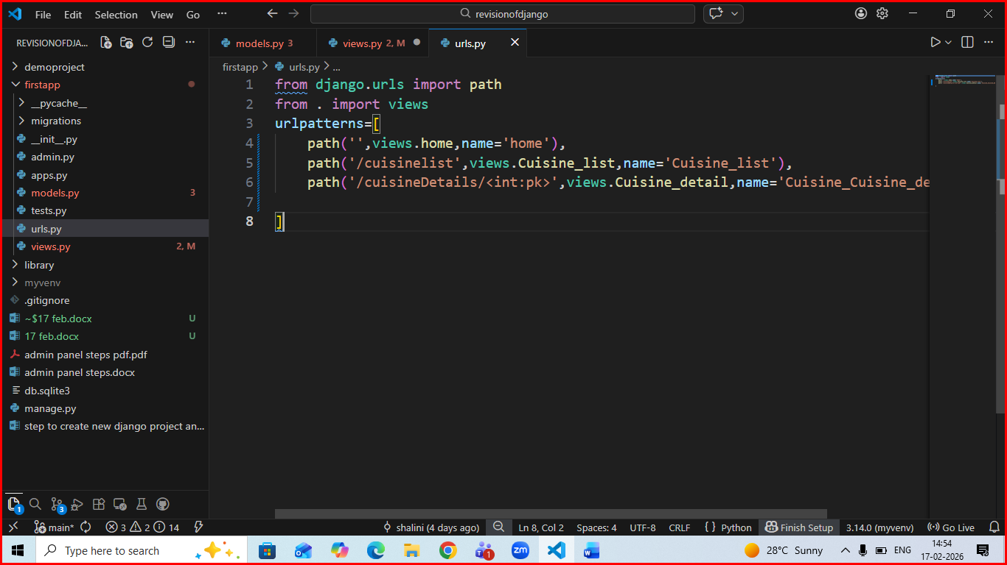

Create folder structure of template like below:
Createa base.html in firstapp folder of template like this:
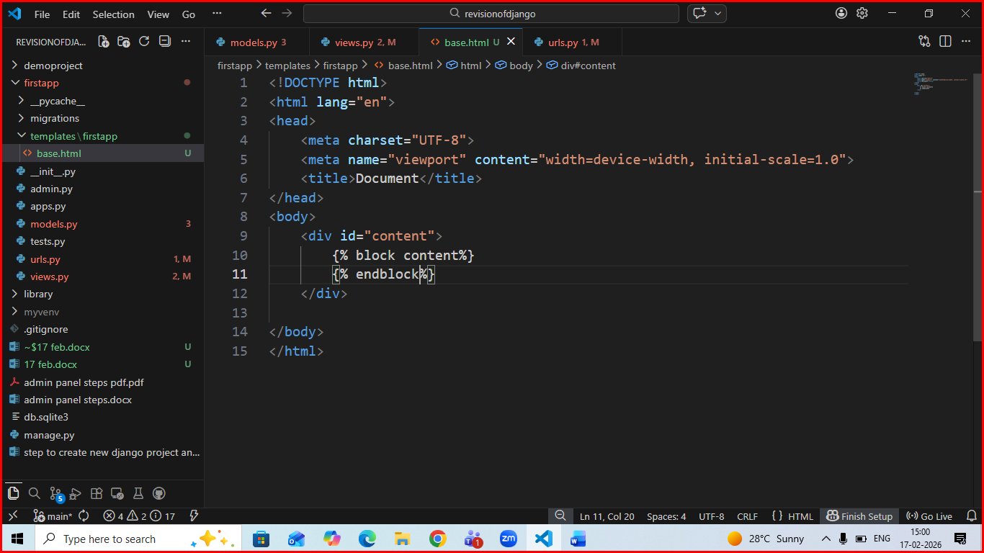

Create cuisine_list.html like below
